Different Types of Pyramid Patterns

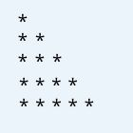

Left Half Pyramid Pattern Using \*

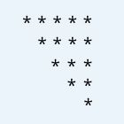

Right Inverted Half Pyramid Pattern Using \*



Left Half Inverted Pyramid Pattern Using \*

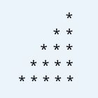

Right Half Pyramid Pattern Using \*

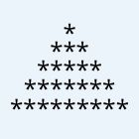

Half Pyramid Pattern

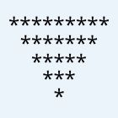

Inverted Half Pyramid Pattern

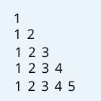

Left Half Pyramid Pattern Using Numbers

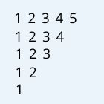

Left Half Inverted Pyramid Pattern Using Numbers

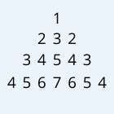

Inverted Pyramid Pattern Using Numbers

Different Types of Diamond Patterns

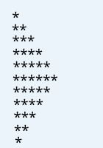

Right Half Diamond Pattern

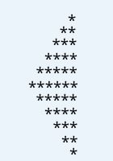

Left Half Diamond Pattern

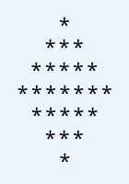

Full Diamond Pattern

Pascal’s Triangle

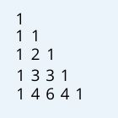

Pascal’s Traingle

Print Floyd’s Triangle

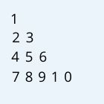

Print Floyd’s Triangle

Different Types of Rhombus Patterns

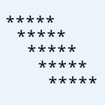

Left inclined Rhombus Pattern

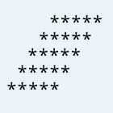

Right Inclined Rhombus Pattern

Different Types of Rectangle Patterns

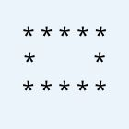

Hollow Rectangle

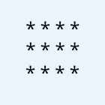

Solid Rectangle

Below are the some Hard, Logical and Tricky pattern programs in c. The below program is just for practicing purposes and build your logic and Also these are Quescol Special.

Different Types of Patterns Using Star And Hyphen

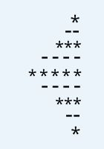

Left inclined Rhombus Pattern

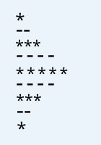

Right Half Diamond Pattern Using Star and Hyphen

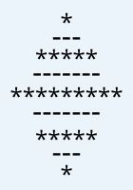

Diamond Pattern Using Star and Hyphen

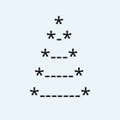

Half Diamond Using Star Hyphen

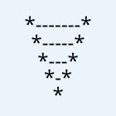

Inverted Half Diamond Using Star Hyphen